**AMETHYST**

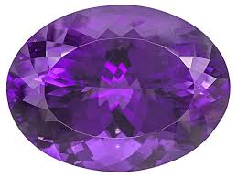

**Name:** Enchanted Amethyst

**Brand:**  Harry Winston

**Model#:** 004

**Color:** Purple-Shade

**Price: $71 million**